VIGNESH.S(192421168)

Ex:No:02 | BOOK BANK REGISTRATION SYSTEM
Date: | BOOK BANK REGISTRATION SYSTEM

AIM:
To draw the diagrams [usecase, activity, sequence, collaboration, class, statechart, collaboration, component, deployment, package ] for the Book bank registration system.
SOFTWARE REQUIREMENTS SPECIFICATION

SL.NO | SOFTWARE REQUIREMENTS SPECIFICATION
1.0 | Hardware Requirements
1.1 | Software Requirements
1.2 | Problem Analysis and Project Plan
1.3 | Project Description
1.4 | Reference

1.0 HARDWARE REQUIREMENTS:
Intel Pentium Processor I3/I5
1.1 SOFTWARE REQUIREMENTS:
Rational rose /Argo UML
1.2 PROBLEM ANALYSIS AND PROJECT PLAN
To simplify the process of applying passport, software has been created by designing through rational rose tool. Initially the applicant login the passport automation system and submits his details. These details are stored in the database and verification process done by the passport administrator, regional administrator and police the passport is issued to the applicant.
1.3 PROJECT DESCRIPTION:
This software is designed for the verification of the details of the student by the central computer. The details regarding the student will be provided to the central computer through the administrator in the book bank and the computer will verify the details of student and provide approval to the office. Then the books that are needed by the student will issue from the office to the him.
1.4 REFERENCES:
IEEE Software Requirement Specification format.
USE CASE DIAGRAM:
This diagram will contain the actors, use cases which are given below Actors: Student, book bank admin.
Use case: Student details, register, verify student id, return previous books, request of books, issue of books, check of book availability

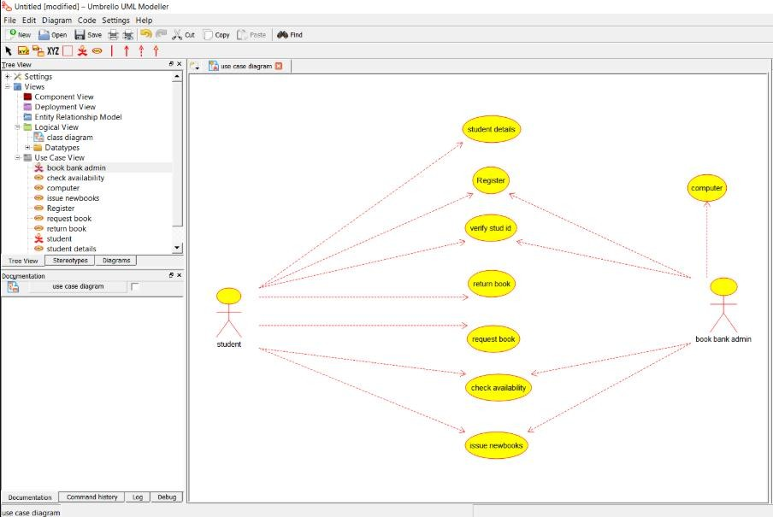
Usecase_192321008

CLASS DIAGRAM:
This diagram consists of the following classes, attributes and their operations.

CLASSES | ATTRIBTES | OPERATIONS
Computer | Student record, Book list | Enter issue(),  Check availability()
Stud | Student details | Request for books(), Register()
Admin | Student details, Book list | Verify student id(), Issue books()

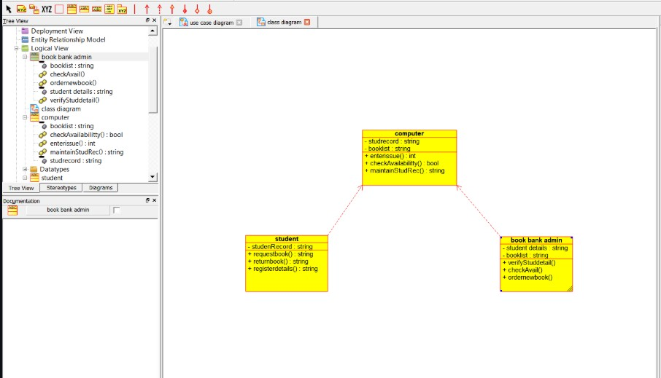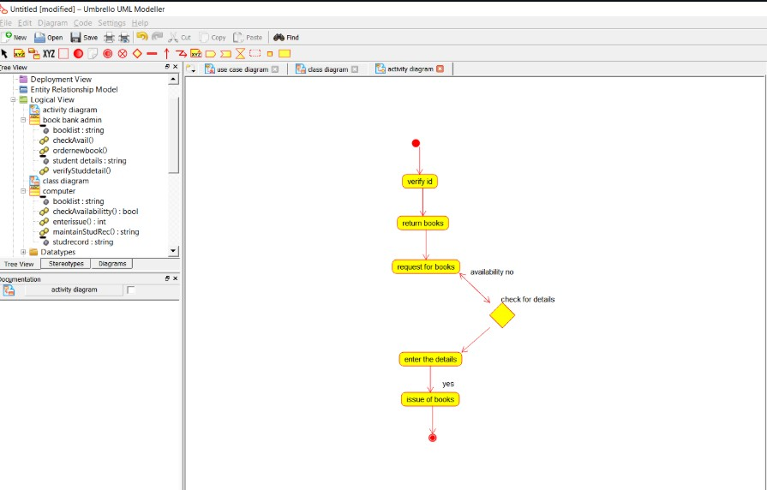

ACTIVITY

DIAGRAM:

This

diagram

will

have

the

activities

as

Start

point,

End

point,

Decision

boxes

as

given

below:

Activities:
Verify id, return books, request for books, enter book issue details in
system, issue books

Decision

box:

Check

availability

of

books

whether

it

is

present

or

not.

192421168
_activity

_class
192421168

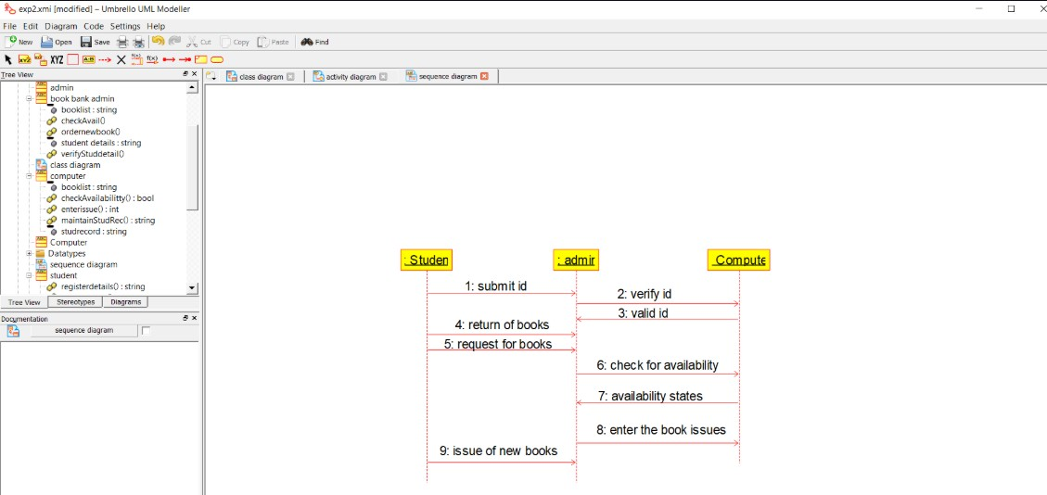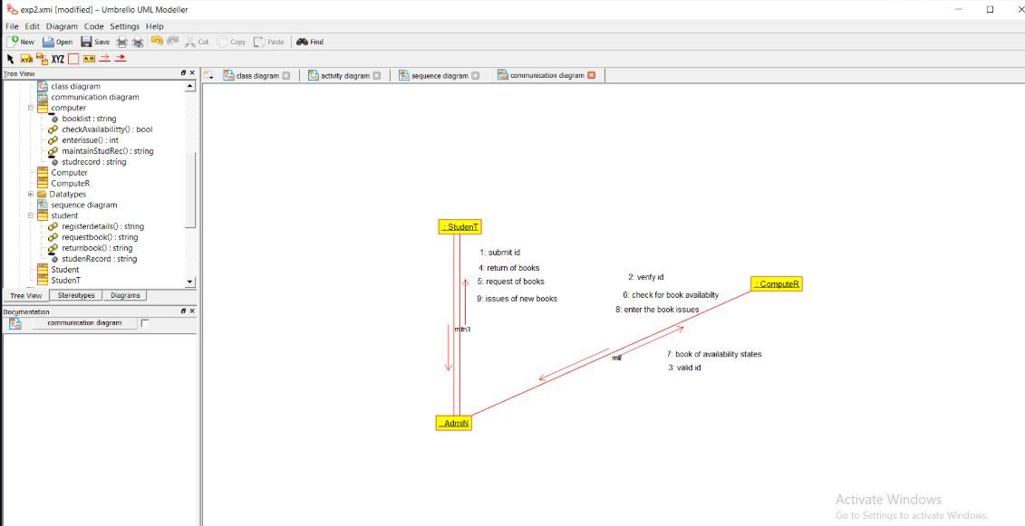
SEQUENCE

DIAGRAM:

This

diagram

consists

of

the

objects,

messages

and

return

messages.

Object:

Stud,

admin,

computer

COLLABORATION

DIAGRAM:

This diagram contains the
objects and actors. This will be obtained by the completion of
the sequence diagram and pressing the F5 key.

STATE

CHART

DIAGRAM

The purpose of

state chart diagram

is to understand the algorithm

involved in performing
a
method. It is also called as state diagram. A state is represented as a round box, which may
contain one or more compartments. An initial state is represented as small dot. An final state is
represented as circle surrounding a small dot.

_sequence
192421168

_

192421168
_collaboration

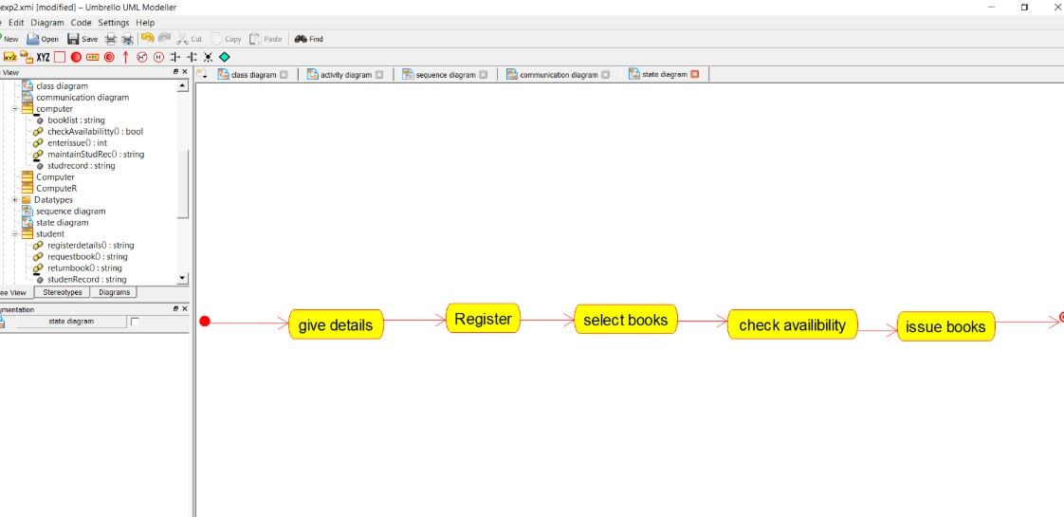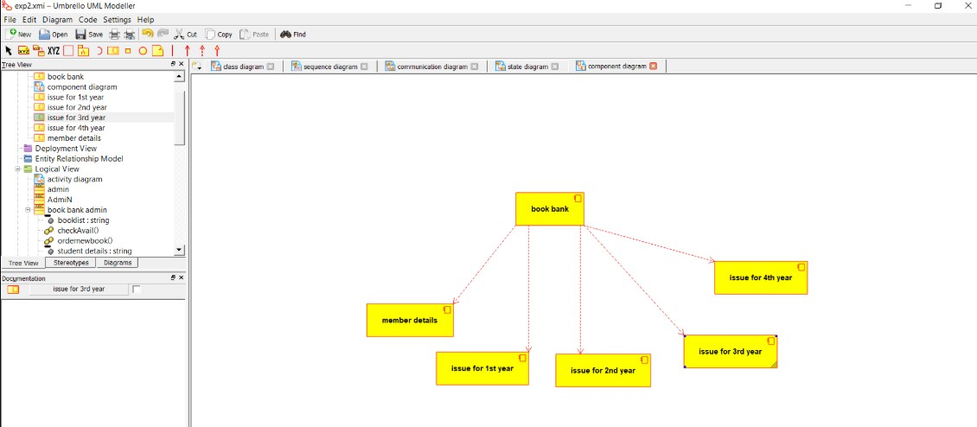

COMPONENT

DIAGRAM

The

component

diagram's

main

purpose

is

to

show

the

structural

relationships

between

the
components of a system. It is represented by boxed figure. Dependencies are represented by
communication association

_state
192421168

192421168
_state

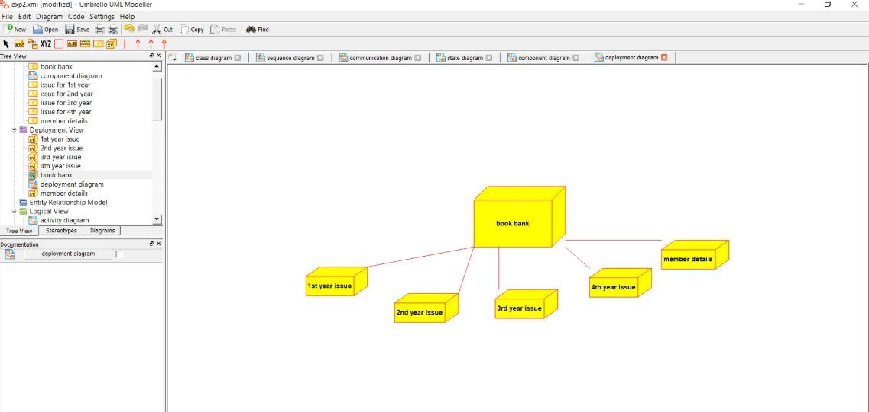

DEPLOYMENT

DIAGRAM

A
deployment diagram in the unified modeling language serves to model the physical
deployment of artifacts on deployment targets. Deployment diagrams show "the allocat
ion of
artifacts to nodes according to the Deployments defined between them. It is represented by 3
-

dimentional box. Dependencies are represented by communication association

PACKAGE

DIAGRAM:

A package diagram in unified
modeling language that depicts the dependencies
between the packages that make up a model. A Package Diagram (PD) shows a grouping of
elements in

the

OO

model, and is

a

Cradle

extension

to

UML. PDs

can

be

used

to

show

groups

of
classes in Class Diagrams (C
Ds), groups of components or processes in Component Diagrams
(
CPDs), or groups of processors in Deployment Diagrams (DPDs
).

There

are

three

types

of

layer.

They

are

o

User

interface

layer

o

Domain

layer

o

Technical

services
layer

_deployment
192421168

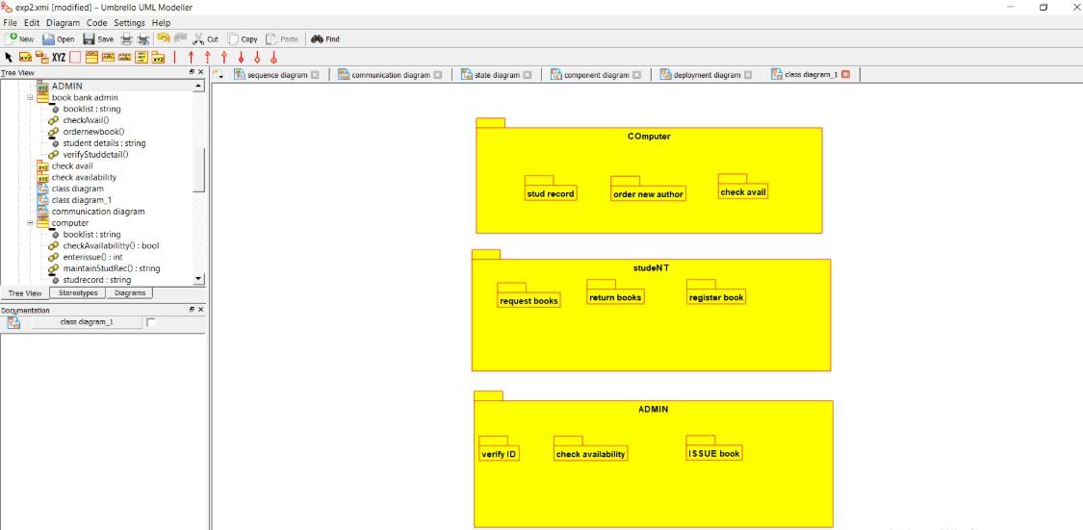

PROGRAM

CODING:

ADMIN:

Public

class

admin

{

Public

integer

student

details;
Public integer book list;
Public void verify stud id()

{

}

Public

void

check

for

availability()

{

}

Public

void issue

books()

{

}

Public

void

order for

new

author()

192421168
_pack

{
}
Public void maintains stud details()
{
}
}
STUDENT:
Public class stud
{
Public integer studdetails;
Public void request for books()
{
}
Public void register()
{
}
COMPUTER:
Public class computer
{
Public integer stud record;
Public integer booklist;
Public void maintain stud rec()
{
}
Public void enter issue()
{
}

Public void order new author()
{
}
Public void check availability()
{
}
}

RESULT:
Thus the diagrams [use case, activity, sequence, collaboration, class, collaboration, component, deployment, package ] for the Book bank registration system has been designed, executed and output is verified.

